**Lab 6 Linux Process Commands:**

**fork(), wait() and exec()**

**Using the sample code from the lecture on processes**

**Q 1 :**

1. **Run the following and clearly explain output.**
2. **Comment out the sleep command in the child process and rerun the program explain the output. :**

*#include <unistd.h>*

*#include <stdio.h>*

*int main()*

*{*

*int i;*

*printf("hello before fork \n");*

*printf("i : %d\n",i);*

*i=fork();*

*printf("\n");*

*if(i==0)*

*{*

*printf("Child has started\n\n");*

*printf("child printing first time \n");*

*printf("getpid : %d getppid : %d \n",getpid(),getppid());*

*sleep(5);*

*printf("\nchild printing second time \n");*

*printf("getpid : %d getppid : %d \n",getpid(),getppid());*

*}*

*else*

*{*

*printf("parent has started\n");*

*printf("getpid : %d getppid : %d \n",getpid(),getppid());*

*printf("\n");*

*}*

*printf("Hi after fork i : %d\n",i);*

*return 0;*

}

Run this program a number of times and explain, in detail, the output. Do not forget to comment the code to explain what each part is doing.

Q 2 using the **fork()** and the **wait()** command referred to in the lecture: write a program that generates two child process (parents).

The parent calculates the factorial of 5;

child 1 calculates the volume of a cube of length 5.

Child 2 calculates the surface area of a cube of length 5.

Both child process must finish before the parent.

Q 3 Run the execvp program discussed in class: enter *two* commands at the shell prompt (e.g. vi wait.c …. The **execvp ()** command (in the execute function) passes *two* parameters **\*argv and argc**. For each of the *two* commands you entered/inputted at the *shell* prompt explain what is stored in each of these parameters.

Q4 ----------------------------- Home Work (if not finished) --------------------------

Set up virtual box and the Ubuntu server on the desktop or on your Run fork1.c and fork2.c on the virtual box and on the linux server observe:. .

1. **Is there a difference between the outputs?**
2. **Why is there a difference between them**

Q3 Sample output on virtual box

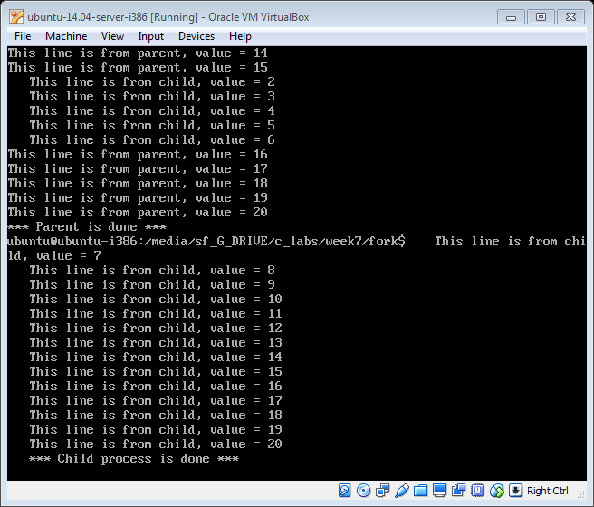

Q4 sample output on virtual box

